Directorate: | Community Wellbeing
Grade: | HC09
Location: | Hereford, Herefordshire
Responsible to: | AMHP, LPS & EDT Services Manager and Deputy Manager

Job Description

Job Role:

Approved Mental Health Professional
Service: AMHP/ASC

Main purpose of the role

- To provide an Approved Mental Health Professional (AMHP) service across Herefordshire Council, to fulfil the statutory duties of the Local Authority, to work with the citizens of Herefordshire in accordance with the Guiding Principles of the Code of Practice and the Mental Health Act (1983), (as amended by the Mental Health Act 2007.

- To work as part of a dedicated AMHP Team and specialise in working with the citizens of Herefordshire, including the undertaking of Mental Health Act assessments, Community Treatment Orders, Breathing Space and associated urgent work. The post holder will also provide Mental Health Act assessment cover for children with mental health needs.

- To work within the Directorate’s Policies, Procedures and Processes with a range of Health and Social Care Professionals, including the Third Sector.

- To provide a quality placement and shadowing opportunities for an AMHP candidate.

Key Duties and Responsibilities

- Accountable for their work and should ensure that work output and quality is of the highest quality and in accordance, where appropriate, with current regulations/legislation/Council standards

- Responsible for their own continuous self-development in order to enhance their own performance and expected to undertake relevant training and development

- Expected to promote the Council’s employment policies, with particular reference to diversity, equality of access and treatment in employment and service delivery and to support/develop a working culture within these services that reflect the Council’s vision

- To work across the County to manage referrals for Mental Health Act assessments. To undertake and support Approved Mental Health Professional duties.

- Under the direction of the designated manager to provide an AMHP service for adults, children and their families using appropriate resources of the Directorate and in partnership with other agencies.

- To take responsibility or support the learning and assessment of the AMHP candidates, including overseeing the learning agreement and the induction process.
- To complete direct observations and reports, and work to agreed deadlines. To deal with any issues that may arise during the placements.

- Must be prepared to participate in partnership work with the Universities. To comply with requests to participate in the assessing and marking of AMHP candidates’ work. To contribute to the AMHP course. To support the Learning and Development Service with AMHP continued professional development training programmes.

- To have a commitment to learning and development, especially with regard to improving best practice, including independent research. To attend the AMHP Meetings and to work with the AMHP, LPS & EDT Services Manager and Deputy Manager, in order to understand and help embed excellent practice.

- To develop up-to-date legal and procedural knowledge that impacts on practice. This will include a wide range of legislation - Children's Act (1989, amended 2004), Human Rights Act (1998), Mental Capacity Act (2005), Data Protection Act (1998), Equality Act (2010) and policies that include Safeguarding, Risk Management, Confidentiality etc. plus any others relevant to this role

- To comply with the Directorate’s Approval and Re-approval procedures. To complete the required training and portfolio in order to maintain AMHP status.

- To work as part of the dedicated AMHP Team to provide a service to citizens experiencing severe and complex mental health needs.

- To work within the principles of the Care Act 2014 to assess and provide a quality service to citizens including assessments under the Mental Health Act 1983, 2007.

- To maintain documentation on AMHP and social work activities in accordance with approved policy and procedures and to use IT systems to complete reports in a prompt and efficient manner.

- To liaise and work in partnership with other social care and health professionals, the police and emergency services as necessary to fulfil the duties of the post.

- To work with citizens, carers and colleagues, including those from other agencies, to ensure equality of opportunity and to improve standards in service delivery.

- To ensure that services are appropriate to people’s individual needs, including those of culture, religion, age, gender, sexuality and disability.

- To observe the relevant professional regulatory body’s Code of Conduct.
- To attend and participate in professional supervision to the standard required by the Directorate. To prepare work for formal supervision under the direction of the designated manager and to keep her/him informed of potential difficulties within the work.

- To carry out any other responsibilities within the scope and spirit of the job purpose and grade as may be required.

- To manage and prioritise own workload adhering to deadlines.
- To provide an AMHP service across Herefordshire Council, to fulfil the statutory duties of the Local Authority, to work with the citizens of Herefordshire in accordance with the Guiding Principles of the Code of Practice and the Mental Health Act (1983), (as amended by the Mental Health Act 2007).

- To work as part of a dedicated AMHP Team and specialise in working with the citizens of Herefordshire, including the undertaking of Mental Health Act assessments, Community Treatment Orders, Breathing Space and associated urgent work. The post holder will also provide Mental Health Act assessment cover for children with mental health needs.

- To provide a quality placement and shadowing opportunities for an AMHP candidate.

Person Specification

Requirements | Essential or Desirable | Identified by  A – Application I – Interview
Qualifications and Training
- Degree in Social Work or equivalent / any other professional qualification. | Essential | A, I
- Evidence of continuous post-qualification CPD. | Essential | A, I
- Must be registered with relevant regulatory body, eg Social Work England. | Essential | A, I
- Approved Mental Health Professional status under the Mental Health Act (1983) | Essential | A, I
Experience & Knowledge
- Experience of working in a Social Care, Health Setting with relevant processional exposure. | Essential | A, I
- Recognised AMHP qualification. | Essential | A, I
- Experience of working with citizens who have mental health needs. | Essential | A, I
- Demonstrate clear knowledge of legislation, policies and procedures, in respect of work with vulnerable citizens. | Essential | A, I
Skills and Abilities
- Ability to undertake complex / specialist assessments incorporating the use of analytical and problem solving skills. | Essential | A, I
- Ability to appropriately advocate social models of intervention. | Essential | A, I
- Ability to influence, negotiate and champion change and good social work practice with citizens with mental health needs. | Essential | A, I
- Ability to work effectively as part of a team. | Essential | A, I
- Ability to work on own initiative, to prioritise workload and meet deadlines. | Essential | A, I
- Ability to maintain appropriate record keeping. | Essential | A, I
- Good oral and written skills, including report writing. | Essential | A, I
- Ability to provide a good quality placement for an AMHP candidate; mentoring, observing and assessing; and to work in partnership with the Universities. | Essential | A, I

All council staff have a duty to promote the welfare of children, young people, and adults with care and support needs at risk of abuse and neglect who cannot take steps to protect themselves. Ensuring you attend mandated safeguarding children and safeguarding adults training to enable you to recognise the concerning behavior, know how to talk about it, and consent/duty to share information effectively. You will also learn about the legalities and procedures the social care staff can take.

Our Values and Behaviours

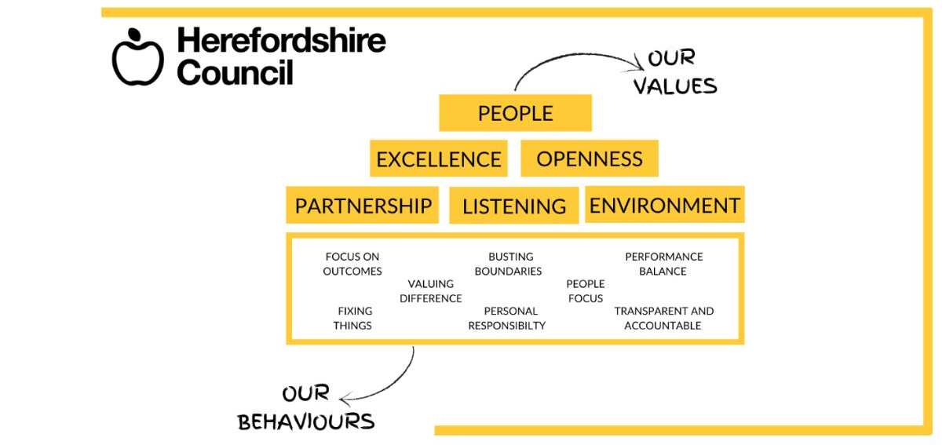
Our values are what we represent as a council and our behaviours are how we act to get things
done to reach our potential.

